**Experiment 10: Develop a water level depth detection system using Ultrasonic sensor.**

**Date : 8.10.2025**

**Circuit:**

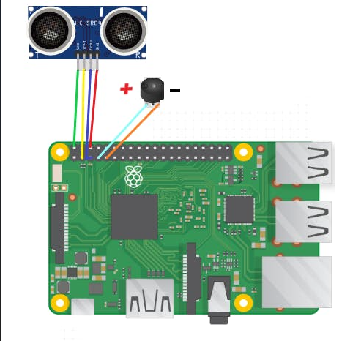

Code:

import RPi.GPIO as GPIO

import time

GPIO.setmode(GPIO.BCM)

TRIG = 2

ECHO = 3

i=0

GPIO.setup(TRIG ,GPIO.OUT)

GPIO.setup(ECHO,GPIO.IN)

GPIO.setup(4 ,GPIO.OUT)

GPIO.output(TRIG, False)

print("Starting.....")

time.sleep(2)

while True:

GPIO.output(TRIG, True)

time.sleep(0.00001)

GPIO.output(TRIG, False)

while GPIO.input(ECHO)==0:

pulse_start = time.time()

while GPIO.input(ECHO)==1:

pulse_stop = time.time()

pulse_time = pulse_stop - pulse_start

distance = pulse_time * 17150

print(round(distance, 2));

time.sleep(1)

if distance < 4:

print("Water will overflow")

GPIO.output(4, True);

time.sleep(0.5)

GPIO.output(4, False);

time.sleep(0.5)

GPIO.output(4, True);

time.sleep(0.5)

GPIO.output(4, False);

time.sleep(0.5)

else:

GPIO.output(4, False);

**Output:**

